Cover Page

Table of content
內容
Abstract 3
1. Introduction 4
2. Literature Review 6
3. Methodology 11
4. Results and Discussion 20
5. Limitations and Future Work 35
6. Conclusion 40
References 42
Appendix A: Full Model Results Summary 44
Appendix B: Trigger Annotation Codebook 48

Abstract
Phishing attacks exploit psychological manipulation rather than technical vulnerabilities, yet many existing detection systems focus primarily on binary classification and provide limited explanation of how users are influenced. This project addresses that gap by developing a machine learning system for identifying psychological triggers in suspicious emails to support phishing awareness.
A manually annotated dataset of 977 phishing and scam emails was constructed from three publicly available sources. Each email was labelled across seven trigger categories: Urgency, Scarcity, Authority, Fear, Social Proof, Reciprocity, and Liking. The task was formulated as a multi-label classification problem and evaluated using rule-based keyword matching, traditional machine learning models, and transformer-based models. Five-fold MultilabelStratifiedKFold cross-validation with Macro F1 was used as the primary evaluation method to account for class imbalance.
The rule-based approach achieved a Macro F1 of 0.5208, demonstrating the limitation of keyword matching for semantic trigger detection. Among traditional models, SVM achieved strong performance with a cross-validated Macro F1 of 0.7211. However, RoBERTa achieved the strongest overall result, with a cross-validated Macro F1 of 0.7388 ± 0.0105, and was selected as the final model. The trained model was deployed in a Streamlit-based interface that presents trigger confidence scores, explanations, and protective guidance.
The project demonstrates the feasibility of using psychological trigger detection as a second-stage awareness support tool, complementing rather than replacing binary phishing classifiers.

1. Introduction
Phishing remains one of the most pervasive and costly forms of cybercrime. According to the 2024 Verizon Data Breach Investigations Report, phishing accounted for 25% of all breaches involving human error (Hylender et al., 2024), while the IBM 2024 Cost of a Data Breach Report estimated an average loss of USD 4.88 million per phishing-originated incident (as cited in Makoshi, 2025). Unlike attacks that exploit technical vulnerabilities, phishing targets human psychology — exploiting trust, fear, urgency, and authority to manipulate individuals into disclosing sensitive information or performing harmful actions. This makes it fundamentally resistant to purely technical countermeasures, and underscores the critical role of user awareness in any comprehensive defence strategy.
Existing approaches to phishing email detection have made substantial progress in binary classification — distinguishing phishing from legitimate emails using machine learning and natural language processing techniques. However, these systems are designed to filter threats, not to educate users. A correctly filtered phishing email leaves the recipient with no understanding of why it was suspicious, what psychological tactics it employed, or how to recognise similar attempts in the future. This represents a significant gap between technical detection capability and the development of long-term user resilience.
Research on human factors in phishing has consistently identified knowledge and situational awareness as key determinants of susceptibility. Desolda et al. (2021) found that lack of knowledge was among the five primary vulnerabilities exploited by phishing attacks, while Zhuo et al. (2023) identified awareness of manipulation strategies as a high-priority intervention target. Cialdini's (2007) foundational work on persuasion principles, subsequently applied to phishing by Ferreira and Teles (2019), Khadka et al. (2023), and Valecha et al. (2022), establishes that phishing emails systematically exploit identifiable psychological triggers — including Authority, Urgency, Fear, Reciprocity, Scarcity, Social Proof, and Liking — to bypass rational judgement.
This project addresses the gap between technical detection and user awareness by developing a machine learning system that identifies and explains the psychological triggers present in suspicious emails. Rather than producing a binary phishing verdict, the system performs multi-label classification across seven trigger categories and presents the results through a Streamlit-based interface that provides per-trigger confidence scores, educational explanations of each detected manipulation strategy, and practical protective guidance. The system is designed as a second-stage explainability module to complement existing phishing detection tools, operating on the assumption that the user already suspects an email may be malicious.
The project makes the following contributions. First, it provides a manually annotated multi-label dataset of 977 phishing and scam emails, labelled across seven psychological trigger categories using a risk-averse, user-centric annotation framework. Second, a comparative evaluation of rule-based, traditional machine learning, and transformer-based approaches for multi-label psychological trigger classification, establishing RoBERTa as the strongest generalising model with a cross-validated Macro F1 of 0.7388. Third, a prototype user awareness interface that translates model outputs into actionable, educational feedback for non-expert users.
The remainder of this report is structured as follows. Section 2 reviews the relevant literature on phishing as a social engineering threat, human factors in phishing susceptibility, persuasion principles in phishing emails, NLP-based detection approaches, and transformer-based text classification. Section 3 describes the methodology, covering dataset collection, manual annotation, preprocessing, model development, threshold optimisation, and system implementation. Section 4 presents and discusses the experimental results. Section 5 identifies the system's limitations and directions for future development. Section 6 concludes the report.

The project artefacts are available through the following links:

Source code repository: https://github.com/hkuspace-pu/project-wongoining.git
Demonstration video: [YouTube link]

2. Literature Review
2.1 Phishing as a Human-Centred Social Engineering Threat
Phishing is a prevalent form of social engineering attack in which adversaries impersonate trusted entities to deceive victims into disclosing sensitive information or performing actions that compromise security (Salloum et al., 2022). Unlike conventional cyberattacks that exploit technical vulnerabilities, phishing fundamentally targets human psychology, rendering it resistant to purely technical countermeasures. The scale of the problem is significant: the Verizon 2024 Data Breach Investigations Report attributed 25% of all human-error breaches to phishing (Hylender et al., 2024), while IBM (2024) estimated average breach costs of USD 4.88 million for phishing-originated incidents (as cited in Makoshi, 2025).
Email remains the predominant attack vector for phishing (Salloum et al., 2022). Common variants include spear phishing, which targets specific individuals; whaling, which focuses on senior executives; and clone phishing, which replicates legitimate communications. The sustained effectiveness of these attacks lies in the attacker's ability to exploit human trust, emotional responses, and cognitive biases — vulnerabilities that fall outside the protective scope of conventional security tools (Desolda et al., 2021).

2.2 Human Factors and Phishing Susceptibility
Desolda et al. (2021) conducted a systematic literature review of human factors in phishing attacks, identifying five primary vulnerabilities: lack of knowledge, lack of resources, insufficient security awareness, absence of established norms, and complacency. The review highlights that, despite the extensive body of research on phishing, existing literature lacks a systematised understanding of human factors, with the majority of studies focusing on technical detection rather than user behaviour and cognition.
Building on this foundation, Zhuo et al. (2023) proposed a three-stage Phishing Susceptibility Model (PSM) that conceptualises user interaction with phishing emails across preparatory, email-checking, and decision-triggering stages, and systematically taxonomises the variables influencing susceptibility. The study finds that susceptibility is not attributable to any single personal trait, but is jointly determined by knowledge, situational context, cognitive load, and message characteristics. Crucially, Zhuo et al. argue that research should prioritise variables amenable to intervention — particularly knowledge and situational awareness — over immutable factors such as personality, given their greater practical value for reducing susceptibility.
Makoshi (2025) further contextualises these findings through the lens of Emotional AI, arguing that attackers circumvent users' rational judgement through emotionally engineered stimuli, often completing psychological manipulation before technical defences can intervene. This underscores the concept of the "human firewall," in which user awareness of manipulation strategies constitutes an indispensable layer of phishing defence.

2.3 Persuasion Principles and Psychological Triggers in Phishing Emails
Cialdini's (2007) Influence: The Psychology of Persuasion provides the foundational theoretical framework for understanding how phishing achieves compliance, identifying six principles of social influence: Authority, Social Proof, Liking, Reciprocity, Scarcity, and Commitment/Consistency. Cybercriminals have long applied these principles systematically within phishing communications to increase victim compliance.
Ferreira and Teles (2019) drew upon the frameworks of Cialdini, Gragg, and Stajano and Wilson to derive a unified list of Principles of Persuasion in Social Engineering (PPSE), which was subsequently applied by two independent researchers to annotate 194 phishing email subject lines (Cohen's Kappa > 0.789). The study found that the most frequently occurring persuasion principles were Authority, Strong Affect, Integrity, and Reciprocity, and demonstrated that the effectiveness of phishing emails depends on the combined deployment of multiple persuasion techniques rather than any single principle in isolation.
Khadka et al. (2023) conducted a systematic survey of persuasion principles as a social engineering strategy in phishing, confirming the prevalence of Social Proof, Liking, Authority, Scarcity, and Reciprocity across phishing corpora. The study specifically attributes the high success rate of spear phishing to attackers' ability to personalise these principles in ways that reduce target scepticism. A subsequent study (Khadka et al., 2025) extended the analysis to full email bodies, finding that attackers tend to deploy Authority combined with Distraction in subject lines, and Deception combined with Distraction in email bodies, revealing a layered strategic structure that single-cue detection systems may fail to capture.
Valecha et al. (2022) validated the utility of persuasion cues for automated phishing detection using a machine learning approach, classifying cues into gain-framed (encompassing Reciprocity, Consistency, and Likeability) and loss-framed (encompassing threat, severity, and immediacy) categories. Models incorporating persuasion cues outperformed baseline models by approximately 5% to 20% in F-score, providing empirical support for the use of persuasion principles as classification features. This finding directly underpins the present study's approach of operationalising psychological triggers as multi-label classification targets.
The present study adopts Cialdini's framework as its annotation schema, defining seven psychological trigger categories: Urgency, Scarcity, Authority, Fear, Social Proof, Reciprocity, and Liking. Although Fear does not appear as a discrete principle in Cialdini's original taxonomy, its consistent empirical prominence in phishing corpora (Khadka et al., 2023; Makoshi, 2025) and its conceptually distinct emotional mechanism justify its treatment as an independent category.

2.4 NLP and Machine Learning for Phishing Email Detection
Salloum et al. (2022) systematically reviewed 100 studies on the application of NLP techniques to phishing email detection published between 2006 and 2022. The review found that feature extraction and selection constituted the dominant research area (86 studies), Support Vector Machines (SVM) were the most widely adopted classification algorithm (50 studies), and TF-IDF and word embeddings were the most commonly employed NLP techniques. The review further noted that existing literature is disproportionately focused on non-semantic feature analysis, with semantic modelling of email body content — and particularly the identification of sender intent — remaining an underexplored direction.
These predominantly feature-based approaches face evident limitations against linguistically sophisticated phishing emails. Salloum et al. (2022) acknowledge that the long-term validity of phishing classifiers is threatened by the continuous evolution of attacker strategies, and advocate for the development of adaptive evaluation frameworks. The present study responds to this limitation by adopting transformer-based deep semantic modelling and grounding classification in persuasion principles, providing an interpretable analytical dimension that extends beyond binary phishing detection.

2.5 Transformer-Based Text Classification
Devlin et al. (2019) introduced BERT (Bidirectional Encoder Representations from Transformers) as a landmark contribution to pre-trained language modelling. Through its bidirectional Transformer architecture, BERT simultaneously considers the left and right contextual relationships of each token, learning context-dependent semantic representations that more effectively capture sentence-level semantic relationships than approaches relying on word frequency or keyword matching. This capacity for contextual understanding provides a technical foundation for text classification tasks involving semantic judgement and linguistic manipulation.
Sanh et al. (2019) introduced DistilBERT as a compressed variant of BERT, employing knowledge distillation to reduce model size and computational cost while retaining the majority of the original model's language understanding capability. For research conducted under constrained computational resources, DistilBERT represents a more practically feasible Transformer option. Liu et al. (2019) proposed RoBERTa as a further optimisation of the BERT architecture, trained on larger corpora with more robust training procedures, achieving superior performance across multiple benchmark tasks; however, its higher computational demands impose practical constraints in resource-limited research environments.
The present study therefore incorporates BERT-family models within a comparative evaluation alongside traditional machine learning approaches, in order to assess the suitability of different text representation methods for the psychological trigger classification task.

2.6 Research Gap and Project Positioning
Three principal gaps can be identified from the reviewed literature.
First, the overwhelming majority of phishing email detection studies frame the problem as binary classification (Salloum et al., 2022), providing no insight into the specific psychological manipulation mechanisms employed within emails and offering limited contribution to the advancement of user security awareness. Khadka et al. (2023) explicitly argue that a deeper understanding of how persuasion principles operate in phishing attacks is essential to effective defence.
Second, both Desolda et al. (2021) and Zhuo et al. (2023) highlight a critical deficiency in existing systems' capacity to cultivate users' active awareness of manipulation strategies. Zhuo et al. specifically identify knowledge and situational awareness as high-priority intervention targets — variables that existing tools rarely address in a structured or explanatory manner.
Third, while Valecha et al. (2022) have demonstrated the machine learning feasibility of persuasion-cue-based detection, their work targets binary phishing classification and does not extend to multi-label trigger identification, nor does it attempt to translate classification outputs into user-facing explanatory content.
The present study directly addresses these gaps by reframing phishing email analysis as a multi-label psychological trigger classification problem, and by comparing traditional machine learning and Transformer-based models for their suitability in this task. The system delivers per-trigger educational explanations and protective guidance through a Streamlit interface, and is positioned as a second-stage explainability module complementing existing phishing detection tools, rather than as a standalone binary classifier.

3. Methodology
3.1 Dataset Collection and Consolidation
Three publicly available sources were used to construct the dataset for this study. The first source was the monkey.org Phishing Archive, comprising .mbox format email archives spanning 2022 to 2024, sourced from a confirmed phishing repository. The second source was the Hugging Face Phishing Dataset, a publicly available NLP dataset in CSV format containing labelled phishing and safe emails. The third source was the University of Twente Phishing Validation Dataset, an academically curated CSV dataset used for phishing research validation purposes.
The .mbox archives were converted to CSV format using a custom extraction pipeline. A custom extract_body() function was developed to handle both text/plain and text/html content types, with HTML content converted to plain text using the html2text library. All three sources were then standardised to a unified two-column format comprising Email Text and Email Type, with label whitespace normalised and duplicate records removed both within and across sources. After consolidation and duplicate removal, the combined source corpus contained more than 18,000 email records. Due to the time-intensive nature of manual psychological trigger annotation, approximately 2,000 records were sampled for manual screening and labelling. During this screening process, records that were excessively short, semantically incomplete, clearly benign, or outside the scope of suspicious email analysis were excluded. This resulted in a manually curated working dataset of 1,964 records prior to the final phishing/scam-only filtering stage.

3.2 Manual Annotation
Manual annotation was conducted on the sampled working dataset using two parallel annotation dimensions: email type classification and psychological trigger labelling. During the annotation process, each email was assigned one email type and was independently assessed for the presence or absence of seven psychological triggers. Trigger labels were therefore not limited only to records eventually retained for model training, as promotional, benign, or non-target emails could also contain persuasive cues. However, only records classified as Phishing Email or Scam Email were retained for the final trigger detection model, because this study focuses on psychological manipulation within suspicious and deceptive email contexts rather than general marketing persuasion.
Email Type Classification
Each email was manually classified into one of four categories using a risk-averse, user-centric labelling framework, in which classification was determined by the potential risk exposure to a non-expert recipient rather than the surface appearance or stated intent of the email. The four categories are defined as follows.
Scam Email (highest priority) encompasses emails whose primary purpose is financial deception, including advance-fee fraud, fictitious investment opportunities, unsolicited high-return schemes, and fabricated narratives designed to elicit monetary participation.
Phishing Email (secondary priority) encompasses emails that induce user interaction with an unverifiable or untrusted destination, including credential harvesting, fake account notifications, malicious file downloads, and deceptive verification flows. Where an email presents superficially as promotional content but its core function directs the user towards a high-risk interaction, it is classified as Phishing Email rather than spam.
Marketing Spam encompasses unsolicited promotional content that does not involve high-risk user interaction and carries no clear deceptive financial narrative.
Spam Other encompasses content that is incoherent, structurally incomplete, or lacks any discernible promotional or deceptive objective.
For model training, only Phishing Email and Scam Email records were retained because the project focuses on psychological manipulation within suspicious and deceptive email contexts. Marketing Spam and Spam Other were excluded to prevent the model from learning general promotional persuasion patterns that are not necessarily associated with phishing or scam intent.

Trigger Annotation
In parallel with email type classification, each record in the sampled working dataset was annotated with seven psychological trigger labels using a binary multi-label matrix format, where a value of 1 indicates the presence of the trigger and 0 indicates its absence. Trigger definitions were adapted from Cialdini's (2007) Principles of Influence and extended using phishing-specific persuasion literature to reflect common manipulation patterns observed in suspicious emails.
Trigger | Definition
Urgency | Time pressure inducing immediate action (e.g., "within 24 hours", "act now")
Scarcity | Implied limited availability to increase perceived value (e.g., "only 3 left", "limited offer")
Authority | Impersonation of a credible institution or official (e.g., "PayPal Security Team", "IRS Notice")
Fear | Threat of negative consequences to compel compliance (e.g., "account suspended", "data breach")
Social Proof | Appeal to others' behaviour to normalise compliance (e.g., "thousands of customers", "join millions")
Reciprocity | Offer of tangible monetary or material benefit creating a sense of obligation (e.g., "free gift", "claim your $500")
Liking | Emotional appeal, flattery, or lifestyle aspiration to build rapport (e.g., "dear friend", "you deserve the best")

The annotation design deliberately adopted a risk-averse and user-centric perspective rather than a purely forensic or infrastructure-based definition of phishing. This decision was made because the intended users of the proposed system are non-expert email recipients who may not inspect technical indicators such as full email headers, domain registration details, or URL redirection chains. From this perspective, the practical risk lies not only in whether an email can be technically proven malicious, but whether its wording is capable of persuading a low-awareness user to perform a risky action. Therefore, emails that strongly encouraged users to click suspicious links, open attachments, verify accounts, submit information, request quotations, or claim benefits were labelled conservatively when such actions could expose the recipient to harm.
This approach also reflects the awareness-oriented objective of the project. The model is not intended to replace forensic phishing investigation or enterprise email gateway filtering. Instead, it aims to identify manipulative language patterns that may affect user judgement. A conservative annotation boundary is therefore appropriate because the cost of under-warning a vulnerable user may be higher than the cost of flagging a suspicious persuasive cue for further consideration.

It is noted that Reciprocity is defined strictly as a tangible, quantifiable benefit; intangible appeals such as lifestyle aspiration, self-improvement, or emotional gratification are classified under Liking to maintain definitional distinctness between the two categories. Each trigger label is annotated independently, such that a single email may carry multiple trigger labels simultaneously or none at all.

Following annotation, only records labelled as Phishing Email or Scam Email were retained for model development. This phishing/scam-only filtering stage yielded 1,001 records prior to preprocessing.
3.3 Data Preprocessing

Following annotation and filtering, the retained Phishing Email and Scam Email records were subjected to a text preprocessing pipeline prior to model training. The pipeline comprised the following steps applied in sequence:

• Removal of all URLs, including http://, https://, and www prefixes
• Removal of all email addresses
• Removal of dataset-specific domain artefacts, specifically the tokens monkey, monkey org, jose, and jose monkey, which were introduced by the monkey.org source archive and identified through TF-IDF keyword analysis as non-semantic contaminants appearing across multiple trigger keyword lists. These tokens were removed because they were source-specific artefacts rather than semantically meaningful indicators of psychological manipulation.
• Removal of excessive whitespace and formatting inconsistencies
• Removal of records whose cleaned text fell below 20 tokens in length, as such entries were deemed insufficient for meaningful semantic classification

Text casing was otherwise preserved after artefact, URL, and email address removal because the final RoBERTa model uses a case-sensitive tokenizer. Following preprocessing, 977 records were retained for model training and evaluation. Twenty-four records were excluded due to insufficient token length after artefact removal.

3.4 Model Development and Evaluation

Task Formulation
A multi-label formulation was selected instead of a single-label classification design because psychological manipulation in phishing emails is rarely expressed through one isolated technique. A single message may simultaneously create time pressure, impersonate an authority, threaten account suspension, and offer a perceived benefit. For example, an account verification email may contain Urgency through a short deadline, Authority through impersonation of a bank or platform, and Fear through the threat of account closure. Treating these triggers as mutually exclusive classes would therefore oversimplify the persuasive structure of phishing messages and force the model to ignore co-occurring manipulation strategies.
The multi-label design better reflects the practical nature of phishing awareness. From a user education perspective, it is useful to show that an email may be risky not only because of one suspicious feature, but because several psychological cues work together to reduce critical judgement. This supports the system’s goal of providing layered explanations rather than a single warning label.

The trigger identification task was formulated as a multi-label binary classification problem, in which each email was independently assessed for the presence or absence of seven psychological trigger categories: Urgency, Scarcity, Authority, Fear, Social Proof, Reciprocity, and Liking. This formulation reflects the multi-dimensional nature of psychological manipulation in phishing and scam emails, where a single message may contain multiple persuasive triggers simultaneously.

For neural models, the loss function used was Binary Cross-Entropy with Logits (BCEWithLogitsLoss). This applies independent sigmoid activation and binary cross-entropy computation to each label, making it suitable for multi-label classification where trigger categories are not mutually exclusive. During evaluation, model logits were converted into independent per-label probabilities using sigmoid activation, and labels with probability scores greater than 0.5 were treated as positive predictions.

Evaluation Strategy

Each model was evaluated using two complementary approaches. First, a single 80/20 train-test split with random_state=42 was used to produce per-label classification reports and allow diagnostic comparison of precision, recall, and F1-score across individual trigger categories.

Second, five-fold cross-validation was used to assess generalisation stability. Since the task is multi-label and the trigger labels are unevenly distributed, five-fold cross-validation was conducted using MultilabelStratifiedKFold (MSKF), with random_state=42, on the final cleaned dataset. MSKF was used instead of standard KFold because it preserves the proportion of positive examples for each trigger label across folds, which is important given the substantial label imbalance in the dataset.

Macro F1-score was used as the primary evaluation metric because it gives equal weight to each trigger category regardless of class frequency. This was particularly important because some triggers appeared much more frequently than others. Precision and recall were also reported to support per-label diagnostic analysis, especially where certain labels demonstrated low recall or imbalanced performance.

3.5 Models and Training Configurations

A sequence of modelling approaches was developed to compare rule-based, traditional machine learning, and transformer-based methods for psychological trigger detection.

Rule-Based Baseline

An initial rule-based baseline was developed using manually defined keyword lists for each psychological trigger. Each email was scanned for trigger-related keywords, and a label was assigned when one or more keywords associated with that trigger were detected. This approach was included as an interpretable baseline to examine whether simple lexical matching could identify psychological cues in suspicious emails.

Traditional Machine Learning Baselines

Traditional machine learning baselines were developed using TF-IDF vectorisation and One-vs-Rest multi-label classification. Four classifiers were evaluated: Naive Bayes, Logistic Regression, Random Forest, and Support Vector Machine (SVM). These models were included to provide a comparison between lightweight feature-based methods and transformer-based semantic models.

The TF-IDF baseline models represented each email as a weighted lexical feature vector. Since the task involved multiple non-mutually exclusive trigger labels, One-vs-Rest classification was used to train an independent binary classifier for each trigger category. The baseline models were evaluated using both the single 80/20 train-test split and five-fold MSKF cross-validation.

Transformer-Based Models

Transformer-based models were evaluated to determine whether contextual language modelling could improve psychological trigger detection. DistilBERT and RoBERTa were fine-tuned for multi-label classification using the seven binary trigger labels. These models were selected because transformer architectures can capture contextual and semantic relationships beyond surface-level keyword matching.

All transformer models used a maximum sequence length of 512 tokens and AdamW optimisation. DistilBERT was evaluated under both 5-epoch and 10-epoch configurations using a batch size of 16 and a learning rate of 2e-5. RoBERTa was evaluated under two configurations: an original configuration using lr=2e-5 and batch size 16, and an optimised configuration using lr=1e-5, batch size 8, linear warmup, and gradient clipping. This comparison was conducted to assess whether a more conservative fine-tuning setup affected training stability and generalisation.

Model Comparison Procedure

The models were compared using the same evaluation framework to ensure methodological consistency. Single split evaluation was used for per-label diagnostic analysis, while five-fold MSKF cross-validation was used to assess generalisation stability. Final model selection was based on cross-validation Macro F1-score, while per-label precision, recall, and F1-score were used to interpret category-specific strengths and weaknesses.

3.6 System Implementation
The user awareness interface was implemented using Streamlit. Upon receiving an email text input, the system applies the same preprocessing pipeline used during training — URL removal, email address removal, domain artefact removal, and whitespace normalisation — prior to RoBERTa tokenisation (max_length=512). The model then produces per-label probability scores, which are compared against the per-label thresholds to determine trigger detection.
The interface presents a Psychological Trigger Intensity score reflecting the overall degree of persuasive language detected, per-trigger confidence scores with Detected/Not Detected classification, educational explanations for each detected trigger, user protection guidance, and a sidebar library of example phishing emails for reference. The metric was designated Psychological Trigger Intensity rather than Risk Score to accurately reflect the system's scope as a trigger analysis tool rather than a phishing classifier. The completed prototype was deployed on Streamlit Cloud to provide a browser-accessible demonstration version of the psychological trigger detection tool. Local execution was also retained for development and testing purposes.
The deployed prototype is available at:
https://phishing-trigger-analyser.streamlit.app/

Component | Technology
Model training | PyTorch + Hugging Face Transformers
Demo application | Streamlit
Hardware | NVIDIA RTX 5070 Ti Laptop GPU
Environment | Anaconda + VSCode (Python 3.10)

The interface was designed to translate model predictions into user-facing awareness feedback rather than technical classification output only. After an email is submitted, the system preprocesses the text using the same pipeline applied during training and passes it to the RoBERTa model for multi-label trigger prediction. The output is presented as per-trigger confidence scores, allowing users to see which manipulation strategies are most strongly indicated. To make the results interpretable for non-expert users, each detected trigger is accompanied by a short explanation of the persuasive mechanism and a practical protective recommendation, such as verifying the sender through an independent channel, avoiding links or attachments, or treating urgent requests with caution. This design choice reflects the project’s awareness-oriented objective: the interface does not simply tell users whether an email is phishing, but helps them understand how the email attempts to influence their judgement.

4. Results and Discussion
4.1 Dataset and Label Distribution
The final training dataset comprised 977 records following preprocessing, consisting exclusively of Phishing Email and Scam Email entries. Table 4.1 presents the label distribution across the seven psychological trigger categories.
Trigger | Positive Count | %
Urgency | 678 | 69.4%
Reciprocity | 607 | 62.1%
Authority | 421 | 43.1%
Liking | 342 | 35.0%
Fear | 319 | 32.7%
Scarcity | 214 | 21.9%
Social Proof | 198 | 20.3%
The distribution reveals substantial class imbalance across trigger categories. Urgency and Reciprocity are present in over 60% of samples, reflecting their prominence as core manipulation strategies in phishing and scam emails, consistent with findings from Khadka et al. (2023) and Valecha et al. (2022). In contrast, Social Proof and Scarcity appear in approximately one in five emails, which has direct implications for model performance on these minority categories, as discussed in Section 4.6.

4.2 Rule-Based Baseline
The rule-based keyword matching approach produced a Macro F1 of 0.5208, establishing the lower performance bound for this task.
Trigger | Precision | Recall | F1
Urgency | 0.793 | 0.648 | 0.71
Scarcity | 0.222 | 0.400 | 0.29
Authority | 0.590 | 0.583 | 0.59
Fear | 0.452 | 0.297 | 0.36
Social Proof | 0.435 | 0.750 | 0.55
Reciprocity | 0.777 | 0.795 | 0.79
Liking | 0.321 | 0.422 | 0.36
Keyword overlap analysis revealed that on average 2.99 triggers were matched per email, with 102 out of 196 test emails matching three or more trigger categories simultaneously. Terms such as email, click, money, and free appeared among the top TF-IDF keywords for five to seven trigger categories concurrently. These results indicate that psychological trigger identification cannot be reliably achieved through lexical matching alone, because generic phishing vocabulary frequently overlaps across multiple trigger categories without carrying category-specific semantic meaning. The rule-based approach was therefore retained only as a baseline rather than used as the final detection method.

The weakness of the rule-based baseline is particularly important because many awareness materials present phishing cues as keyword-like warning signs, such as “urgent”, “verify”, “limited”, or “free”. While these indicators are useful for introductory training, the experimental results show that keyword matching alone is too brittle for psychological trigger detection. The same word can serve different persuasive functions depending on context. For example, “free” may indicate Reciprocity when it refers to a tangible benefit, but it may also appear in irrelevant spam or product promotion. Similarly, “click” is common in many phishing emails but does not by itself identify whether the manipulation strategy is based on Fear, Authority, Urgency, or Reciprocity.
This explains why the rule-based approach produced both over-detection and under-detection. It over-detected triggers when generic phishing vocabulary appeared across categories, and under-detected triggers when the persuasive meaning was expressed indirectly. For instance, an email may create fear without using explicit threat keywords, or create authority through institutional formatting and sender framing rather than direct terms such as “official” or “security team”. This limitation supports the decision to evaluate machine learning and transformer-based approaches capable of learning broader contextual patterns.

4.3 Traditional Machine Learning Models
Model | Single Split | CV Mean | ±SD
Naive Bayes | 0.5784 | 0.5536 | ±0.0158
Logistic Regression | 0.6805 | 0.6315 | ±0.0120
Random Forest | 0.6985 | 0.6738 | ±0.0108
SVM | 0.7360 | 0.7211 | ±0.0164
SVM achieved the strongest performance among traditional machine learning models, with a single-split Macro F1 of 0.7360 and a cross-validated mean of 0.7211 (±0.0164), consistent with the established effectiveness of linear SVMs for high-dimensional sparse text classification (Salloum et al., 2022). Logistic Regression and Random Forest demonstrated stable but lower performance, while Naive Bayes improved substantially over the rule-based baseline, suggesting that probabilistic lexical weighting provided useful signal but was insufficient for stronger trigger-level discrimination.
The overall comparison of the traditional machine learning baselines is shown in Figure 4.1.
Per-label results for SVM, the strongest traditional baseline, are reported below.
Trigger | Precision | Recall | F1
Urgency | 0.86 | 0.87 | 0.86
Scarcity | 0.57 | 0.46 | 0.51
Authority | 0.86 | 0.81 | 0.83
Fear | 0.88 | 0.66 | 0.75
Social Proof | 0.69 | 0.60 | 0.64
Reciprocity | 0.83 | 0.91 | 0.87
Liking | 0.73 | 0.64 | 0.68
SVM demonstrated strong performance on the two highest-frequency triggers, Urgency (F1 = 0.86) and Reciprocity (F1 = 0.87). Fear showed notably high precision (0.88) but lower recall (0.66), suggesting that SVM correctly identified Fear when confident but missed instances where fear-inducing language was expressed in less prototypical forms. Scarcity (F1 = 0.51) and Social Proof (F1 = 0.64) recorded the lowest per-label scores, consistent with their lower positive sample rates and discussed further in Section 4.6.

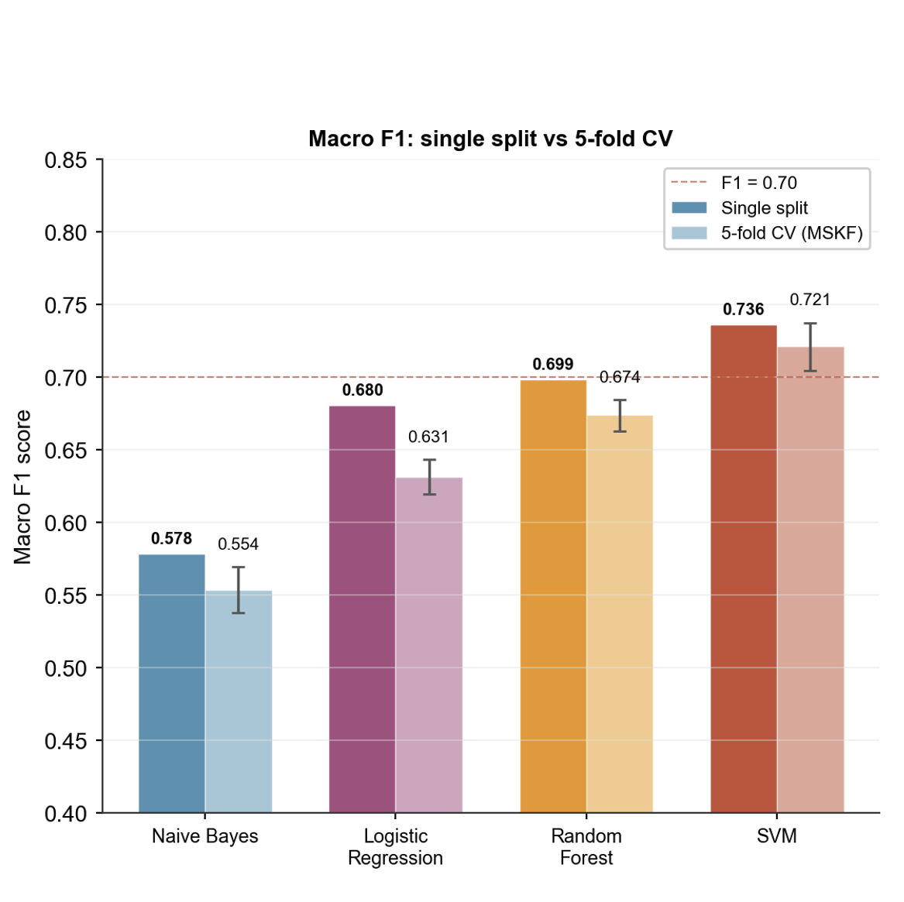
Figure 4.1: Traditional machine learning baseline comparison using TF-IDF and One-vs-Rest classification

4.4 Transformer-Based Models
4.4.1 DistilBERT
Config | Single Split | CV Mean | ±SD
5 epochs | 0.6903 | 0.6899 | ±0.0071
10 epochs | 0.6867 | 0.7107 | ±0.0164
The 5ep configuration achieved the lowest cross-validation variance of all models evaluated (±0.0071), indicating highly consistent but conservatively performing predictions. The 10ep configuration improved cross-validated mean to 0.7107, suggesting that additional epochs allowed the model to learn more discriminative representations. Both configurations nonetheless underperformed SVM on cross-validated Macro F1, suggesting that the dataset size constrained DistilBERT's ability to realise its full capacity for contextual language modelling. The learning curve suggested limited additional benefit from extended fine-tuning beyond the middle training epochs.
The per-label results for DistilBERT 5ep highlight a particularly striking pattern for Scarcity: despite reasonable precision (0.78), recall was severely low (0.20), indicating that the model developed a narrow, high-confidence decision boundary for this category due to limited positive training examples.
Trigger | Precision | Recall | F1
Urgency | 0.85 | 0.80 | 0.83
Scarcity | 0.78 | 0.20 | 0.32
Authority | 0.83 | 0.80 | 0.81
Fear | 0.77 | 0.64 | 0.70
Social Proof | 0.68 | 0.53 | 0.59
Reciprocity | 0.83 | 0.87 | 0.85
Liking | 0.64 | 0.84 | 0.73
4.4.2 RoBERTa
Config | Single Split | CV Mean | ±SD
Original (lr=2e-5) | 0.7129 | 0.7388 | ±0.0105
Optimised (lr=1e-5) | 0.7293 | 0.6924 | ±0.0162

Fold | Original | Optimised
Fold 1 | 0.7571 | 0.6692
Fold 2 | 0.7242 | 0.7174
Fold 3 | 0.7371 | 0.6962
Fold 4 | 0.7378 | 0.6972
Fold 5 | 0.7378 | 0.6818
Mean | 0.7388 | 0.6924
±SD | ±0.0105 | ±0.0162
The contrast between the two RoBERTa configurations is instructive. The optimised configuration (lr=1e-5) achieved a higher single-split Macro F1 (0.7293 vs. 0.7129), but its cross-validation performance was substantially lower (0.6924 vs. 0.7388) and more variable (±0.0162 vs. ±0.0105). This suggests that the optimised configuration may have fitted the specific train-test split more closely, but did not generalise as consistently across folds. This divergence illustrates precisely why cross-validation was adopted as the primary evaluation criterion rather than single-split performance.
The original configuration's cross-validation standard deviation of ±0.0105 is the second lowest across all models, indicating robust and consistent generalisation. RoBERTa also demonstrated notably rapid convergence, reaching strong validation F1 by epoch 2–3, consistent with its more extensive pre-training corpus relative to DistilBERT (Liu et al., 2019).

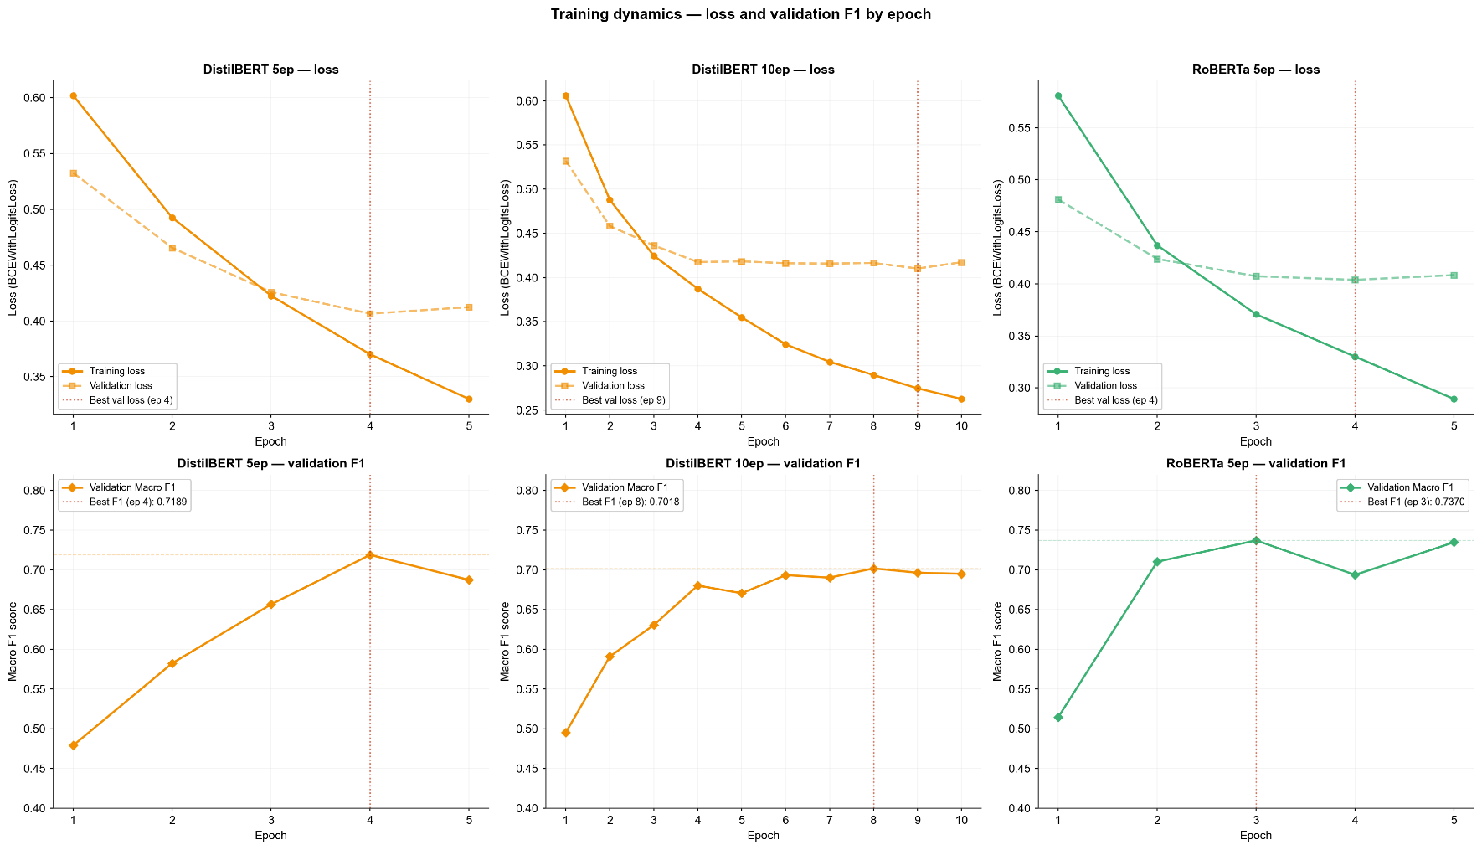

Figure 4.2: Training and validation learning curves for the selected RoBERTa model.

Per-label results for RoBERTa original:
Trigger | Precision | Recall | F1
Urgency | 0.92 | 0.70 | 0.80
Scarcity | 0.65 | 0.43 | 0.52
Authority | 0.82 | 0.75 | 0.78
Fear | 0.73 | 0.70 | 0.71
Social Proof | 0.77 | 0.42 | 0.55
Reciprocity | 0.90 | 0.81 | 0.85
Liking | 0.74 | 0.81 | 0.78
RoBERTa achieved the highest precision on Urgency (0.92) and Reciprocity (0.90) among all models. Notably, RoBERTa achieved a better precision-recall balance for Fear (0.73/0.70) compared to SVM (0.88/0.66), suggesting that contextual language modelling is particularly beneficial for detecting fear-inducing language whose surface form varies considerably across emails.

4.5 Overall Model Comparison and Final Model Selection
Model | Single Split | 5-Fold CV (MSKF) | ±SD
Rule-based | 0.5208 | — | —
Naive Bayes | 0.5784 | 0.5536 | ±0.0158
Logistic Regression | 0.6805 | 0.6315 | ±0.0120
Random Forest | 0.6985 | 0.6738 | ±0.0108
SVM | 0.7360 | 0.7211 | ±0.0164
DistilBERT 5ep | 0.6903 | 0.6899 | ±0.0071
DistilBERT 10ep | 0.6867 | 0.7107 | ±0.0164
RoBERTa optimised | 0.7293 | 0.6924 | ±0.0162
RoBERTa original | 0.7129 | 0.7388 | ±0.0105
The original RoBERTa configuration was selected as the final model based on its highest cross-validated Macro F1 of 0.7388 and second-lowest standard deviation across all models (±0.0105). Cross-validation performance was prioritised over single-split performance as the primary selection criterion, as it provides a more reliable estimate of generalisation for a dataset of this size.
SVM achieved a higher single-split Macro F1 than RoBERTa original (0.7360 vs. 0.7129) and its cross-validated performance (0.7211) remained competitive without requiring GPU resources. SVM therefore represents a strong and computationally efficient alternative warranting consideration in resource-constrained deployment scenarios. However, RoBERTa's superior cross-validation mean and lower variance indicate more consistent generalisation, and its contextual representations provide a more principled foundation for detecting psychologically nuanced language patterns.

Although SVM achieved strong baseline performance, it was not selected as the final model. The SVM baseline relies on TF-IDF lexical features, which are effective for high-dimensional sparse text classification but remain closely tied to surface vocabulary patterns in the training corpus. This presents a limitation in the phishing context, where email templates, wording, and persuasive framing continuously evolve. The increasing availability of generative AI may further accelerate this evolution by enabling attackers to produce more varied and natural-sounding phishing messages, reducing the reliability of fixed keyword or template-based signals. In contrast, RoBERTa provides contextual semantic representations and is better aligned with the objective of detecting psychological trigger patterns expressed through varied language. Therefore, despite SVM's competitive performance, RoBERTa was selected as the final model due to its stronger cross-validated Macro F1 and better fit for semantic trigger detection.

The strong performance of SVM is an important finding rather than a weakness of the final model selection. It shows that psychological trigger detection contains a substantial lexical component: certain forms of Urgency, Authority, Fear, and Reciprocity are often expressed through recurring vocabulary and phrase patterns. In a relatively small dataset, TF-IDF features combined with a linear SVM can therefore provide a robust and computationally efficient baseline. This is consistent with prior NLP phishing detection literature, where SVM has frequently performed strongly on sparse text classification tasks.
However, the final model was selected not only on present performance, but also on alignment with the semantic nature of the research objective. The project does not aim merely to detect repeated phishing templates; it aims to identify psychological manipulation strategies that may be expressed through varied wording. This distinction is important because phishing emails are not static. Attackers can modify templates, rephrase threats, change the surface wording of incentives, or use generative AI to produce more natural and diverse messages. In such a setting, a method that depends heavily on lexical distributions observed in the training corpus may face greater generalisation risk.
RoBERTa was therefore selected because it achieved the strongest cross-validated Macro F1 while also providing a better conceptual fit for semantic trigger detection. Its contextual representations allow the model to consider how words function within the surrounding sentence, rather than treating them primarily as independent weighted terms. This does not imply that SVM is ineffective; rather, SVM remains a strong baseline, while RoBERTa is more appropriate for the project’s future-facing objective of detecting manipulation patterns across varied linguistic expressions.

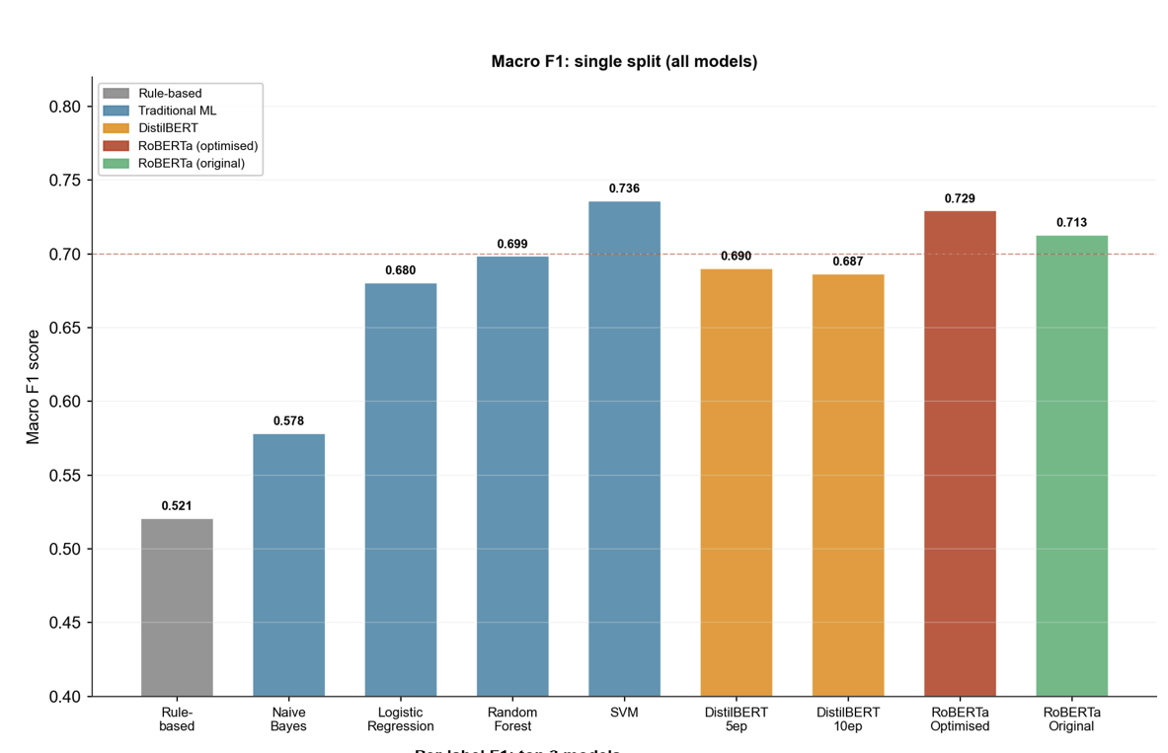

Figure 4.3: Overall model comparison using the single 80/20 train-test split.

4.6 Per-label Performance and Trigger Difficulty
Across all models, Urgency and Reciprocity were detected most reliably, benefiting from the highest positive sample counts and relatively explicit linguistic patterns. Authority performed consistently well across both traditional and transformer models, reflecting the specificity of impersonation language in phishing emails. Fear and Liking showed intermediate performance, with Fear's detection depending more heavily on contextual interpretation than fixed lexical cues — a task where RoBERTa demonstrated a clearer advantage over SVM.
In contrast, Scarcity and Social Proof remained consistently the most difficult trigger categories across all models. Two compounding factors account for this pattern. First, class imbalance: with only 214 (21.9%) and 198 (20.3%) positive examples respectively, these categories provide substantially fewer training signals than majority triggers. Second, semantic overlap with non-phishing content: scarcity language (e.g., limited offer, exclusive) and social proof language (e.g., join millions, trusted by thousands) closely resemble legitimate marketing communication. The consistent precision-recall imbalance observed for these minority triggers — particularly Scarcity's severely low recall in DistilBERT (0.20) and Social Proof's low recall in RoBERTa (0.42) — suggests that models develop conservative decision boundaries for these categories, predicting positive only when high-confidence lexical signals are present.

The difficulty of Scarcity and Social Proof should not be interpreted only as a data imbalance issue. Although both categories had fewer positive examples, they are also semantically harder to distinguish from legitimate marketing language. Scarcity cues such as “limited offer”, “exclusive access”, or “only available today” are common in ordinary advertising, meaning that their presence does not automatically imply malicious intent. Similarly, Social Proof expressions such as “trusted by thousands” or “join millions of users” are widely used in commercial communication. As a result, these triggers require the model to distinguish between persuasive language that is merely promotional and persuasive language embedded in a suspicious or deceptive email context.
These findings also have implications for future dataset design. Improving minority-label performance should not rely only on adding more positive examples, but also on collecting stronger boundary cases. For Scarcity, this would include both malicious emails using limited-time pressure and legitimate promotional emails using similar wording without deceptive intent. For Social Proof, useful contrastive examples would include genuine customer-review or community-based marketing messages alongside suspicious emails that use popularity claims to build false credibility. Such examples would help the model learn not only the presence of persuasive language, but also whether that language functions as part of a deceptive manipulation strategy. This is especially important because the project’s goal is not to detect persuasion in general, but persuasion within suspicious email contexts.

This helps explain why models tended to perform more conservatively on these labels. A model may learn that Scarcity and Social Proof should only be predicted when the signal is explicit, because weaker examples overlap heavily with non-malicious promotional discourse. This is especially challenging in the present dataset because the final training set focuses on phishing and scam emails rather than including a balanced set of legitimate marketing emails. Future work could therefore improve these categories not only by increasing the number of positive examples, but also by adding carefully selected negative examples containing legitimate scarcity and social proof language. Such contrastive examples would help the model learn the boundary between general persuasion and suspicious manipulation.

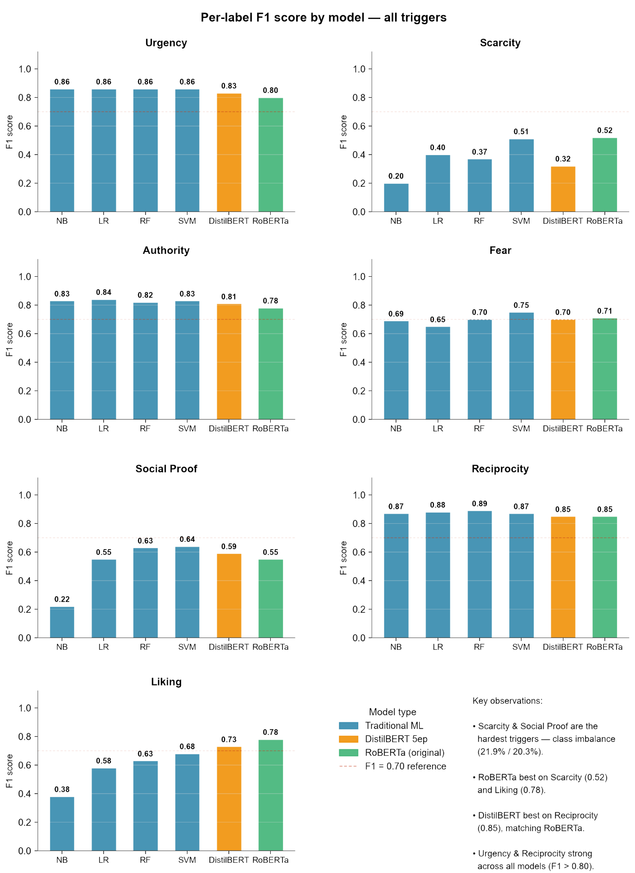
Figure 4.4: Per-label F1 comparison across selected models

4.7 Effect of Preprocessing
The preprocessing stage improved result reliability by removing source-specific artefacts that otherwise appeared as misleading high-weight TF-IDF terms. Tokens such as monkey, monkey org, jose, and jose monkey were not semantically related to psychological manipulation, yet appeared across multiple trigger keyword lists before removal. Their exclusion reduced the likelihood that models would learn dataset-source artefacts as proxy signals rather than genuine psychological trigger patterns, and reinforces the importance of corpus-specific artefact analysis as a preprocessing step when training on emails sourced from archived collections.

4.8 Summary of Findings
The experimental evaluation produced five main findings. First, rule-based keyword matching was insufficient for psychological trigger detection, as generic phishing vocabulary overlapped heavily across trigger categories and could not reliably capture category-specific semantic meaning. Second, TF-IDF with SVM provided a strong and computationally efficient baseline, demonstrating that lexical features remain useful for several high-frequency trigger categories. Third, the original RoBERTa configuration achieved the strongest cross-validated Macro F1 and was therefore selected as the final model, as its performance was more consistent across folds than the alternative transformer configuration.

Fourth, trigger difficulty was not uniform across categories. Urgency and Reciprocity were detected more reliably because they were frequent in the dataset and often expressed through clearer linguistic patterns. In contrast, Scarcity and Social Proof remained the most challenging categories due to their lower positive sample counts, less explicit semantic cues, and overlap with other persuasive triggers within phishing and scam emails. Finally, the preprocessing stage helped reduce source-specific artefacts, supporting the need for corpus-specific cleaning when training models on archived email datasets.

5. Limitations and Future Work
5.1 False Positive Behaviour on Legitimate Emails
The most significant operational limitation of the system is its tendency to produce elevated trigger scores for legitimate emails containing institutional language, time references, or authority indicators. This behaviour arises because the training dataset comprises exclusively phishing and scam emails, meaning the model has never been exposed to legitimate contextual usage of persuasive language patterns and cannot distinguish between manipulative and benign instances of the same linguistic features.
As a concrete illustration, a genuine academic invitation email containing a response deadline was processed by the system and assigned a Psychological Trigger Intensity score of 75.8%, with Urgency (82.9%), Authority (82.3%), Fear (71.1%), and Reciprocity (67.0%) all detected. The institutional deadline triggered Urgency; the college name and contact details triggered Authority; and the polite formal register triggered Reciprocity. None of these detections reflect genuine psychological manipulation.
This limitation is a direct and acknowledged consequence of the system's intended scope. As established in Section 3.2, the system assumes input is a suspected phishing email and is designed as a second-stage explainability module rather than a standalone phishing classifier. In an integrated deployment, a binary phishing classifier would first determine whether an email is suspicious before passing it to the trigger analysis module, preventing false positives on legitimate emails from reaching the system. The development of such an integration is identified as the primary future development objective in Section 5.4.

5.2 Dataset and Annotation Limitations
Several limitations arise from the dataset construction process. The final training dataset of 977 records, while sufficient to demonstrate the feasibility of the approach, is relatively small for fine-tuning transformer-based models and may not fully represent the lexical and stylistic diversity of real-world phishing and scam emails. This is particularly evident in the underperformance of minority trigger categories such as Scarcity and Social Proof, which had fewer than 215 positive training examples each.
The annotation was conducted by a single annotator, which precludes the measurement of inter-rater reliability. While a predefined codebook and fixed boundary rules were applied consistently throughout the labelling process, the absence of a second independent annotator means that systematic annotation biases cannot be ruled out. Future work should incorporate at least two independent annotators and report Cohen's Kappa as a formal measure of annotation agreement.
Additionally, the source datasets predominantly contain English-language emails, and the final training dataset was treated as English-language content. As a result, the annotation scheme and trained model may not generalise to phishing or scam emails written in other languages. Since persuasion cues can be language- and culture-specific, future work would require a multilingual annotation framework and language-specific validation before the system could be reliably applied beyond English-language emails.

5.3 Practical Positioning
A further practical consideration is the increasing availability of general-purpose AI chatbots, which users may already use to ask whether an email is safe. However, this project is not designed as a first-layer phishing detector that simply determines whether an email is safe or unsafe. Low-awareness users may not know how to ask follow-up questions about the psychological manipulation strategies behind suspicious messages. Therefore, the proposed system is positioned as a second-layer awareness support tool. Its contribution lies in explaining suspicious emails through a fixed set of psychological trigger categories, helping users understand not only that an email may be risky, but also how it attempts to influence their judgement. In this sense, the system aims to support learning and awareness rather than replace conventional phishing filters or general AI assistants.

A small exploratory comparison with general-purpose AI chatbots could further clarify this positioning. For example, future work could test a small set of suspicious emails using accessible systems such as Gemini and Perplexity, asking first whether the email appears safe and then comparing whether the response identifies specific psychological triggers. Such a comparison should not be treated as a formal benchmark, because chatbot behaviour depends heavily on model version, prompt wording, safety policy, and conversation context. However, it could provide a practical demonstration of the difference between a general safety judgement and a structured awareness explanation. This would be especially relevant for low-awareness users, who may ask only whether an email is safe but may not know how to ask why it feels persuasive or which manipulation tactics are being used.

5.4 Future Development
Several directions are identified for future development of the system.
Integration with a binary phishing classifier.
The most impactful near-term improvement would be to integrate the trigger analysis module as a second-stage layer following a binary phishing classifier. In this architecture, the classifier first determines whether an email is suspicious; the trigger analysis module then provides psychological context to explain the manipulation strategies employed. This integration would directly resolve the false positive limitation described in Section 5.1 and establish a more robust end-to-end user awareness pipeline.

Dataset expansion and active learning.
Expanding the annotated dataset, particularly for minority trigger categories such as Scarcity and Social Proof, would improve model performance on these underrepresented classes. Active learning — in which the model identifies the most informative unlabelled examples for annotation — provides an efficient strategy for extending coverage without requiring exhaustive manual labelling of the full source corpus.
Inter-rater reliability measurement.
Future annotation rounds should involve at least two independent annotators, with Cohen's Kappa reported as a formal measure of labelling consistency. This would strengthen the validity of the annotation scheme and support the potential publication of the dataset as a research resource.

Out-of-distribution evaluation.
The training data spans 2022–2024. Evaluation on more recent phishing emails from 2025–2026 would assess how well the model generalises to evolving attack patterns and novel manipulation strategies not represented in the training corpus.

Multilingual support.
The current system was developed primarily for English-language emails. Given that phishing attacks are a global phenomenon, extending the annotation framework and model training to support multiple languages would substantially broaden the system's applicability. This would require language-specific trigger definitions and validation to ensure that persuasion cues are interpreted consistently across languages and cultural contexts.

Exploratory comparison with general-purpose AI chatbots.
A small-scale exploratory comparison with accessible tools such as Gemini and Perplexity could be conducted to examine how general-purpose chatbot responses differ from the structured trigger-based explanations produced by the proposed system. This would not be intended as a formal benchmark, but as a practical demonstration of the system’s awareness-oriented contribution.

User evaluation and explanation calibration. Future development should also include a real end-user evaluation to determine whether the trigger-based explanations improve phishing awareness in practice. Although the current prototype provides confidence scores, trigger explanations, and protective guidance, this study evaluates the model primarily through classification metrics rather than user behaviour. As a result, it cannot yet demonstrate whether users become more cautious, more confident, or more capable of recognising similar manipulation strategies after viewing the system output. A future user study could ask participants to assess suspicious emails before and after using the tool, measuring changes in perceived risk, willingness to click links or open attachments, and ability to identify the psychological tactics used in the message. This would provide stronger evidence for the system’s intended awareness-support role.
Such evaluation should also examine how non-expert users interpret model confidence scores. A high trigger confidence may be easy to understand as a warning, but moderate confidence values may be more ambiguous. Some users may interpret a lower score as meaning that the email is safe, even though the system is not designed to provide a binary safety verdict. Future work could therefore test alternative presentation formats, such as low/medium/high confidence bands, clearer uncertainty messages, or short examples explaining why a trigger was detected. This is important because the usability of the system depends not only on whether the model predicts the correct labels, but also on whether the explanation leads users to make safer decisions. Overly sensitive warnings may reduce trust in the tool, while overly conservative warnings may fail to alert users to subtle manipulation strategies. A user-centred evaluation would therefore help refine both the technical model and the explanation interface.

6. Conclusion
This project set out to address a gap in existing phishing detection research: while binary classification systems have achieved strong technical performance, they provide users with no understanding of the psychological manipulation strategies employed against them. By reframing phishing email analysis as a multi-label psychological trigger classification problem, the present work demonstrates that it is feasible to automatically identify the persuasion principles embedded in suspicious emails and to present this information in a form that enhances user awareness.
The system was developed through a four-stage process encompassing dataset construction, manual annotation, model evaluation, and interface implementation. A dataset of 977 phishing and scam emails was assembled from three publicly available sources and annotated with seven psychological trigger categories — Urgency, Scarcity, Authority, Fear, Social Proof, Reciprocity, and Liking — grounded in Cialdini's (2007) Principles of Influence and extended to reflect phishing-specific manipulation patterns identified in the literature. A comparative evaluation of rule-based, traditional machine learning, and transformer-based approaches established RoBERTa (original configuration, lr=2e-5) as the final model, achieving a five-fold MultilabelStratifiedKFold cross-validated Macro F1 of 0.7388 (±0.0105) — the strongest and most consistent performance across all models evaluated. The trained model was deployed within a Streamlit-based user awareness interface that provides per-trigger confidence scores, educational explanations, and protective guidance in response to email text input.
Several findings from the evaluation carry broader implications. The strong performance of SVM as a traditional baseline (CV Macro F1: 0.7211) demonstrates that computationally efficient methods remain competitive for this task, particularly in resource-constrained settings. The consistent underperformance of Scarcity and Social Proof across all models reflects the compounding challenges of class imbalance and semantic proximity to legitimate promotional language, and motivates future work on class-rebalancing strategies and dataset expansion. The false positive behaviour observed on legitimate institutional emails — a direct consequence of training exclusively on phishing and scam content — reinforces the system's positioning as a second-stage explainability module rather than a standalone classifier, and underscores the importance of integrating trigger analysis with an upstream binary phishing detector.
The project contributes to the growing body of research advocating for human-centred approaches to phishing defence. As Desolda et al. (2021) and Zhuo et al. (2023) have established, knowledge and situational awareness are among the most tractable variables for reducing phishing susceptibility. By making the psychological mechanisms of phishing visible and interpretable to end users, the present system represents a step towards closing the gap between technical detection capability and user-level understanding — a gap that binary classifiers alone cannot address.

Beyond its technical results, the project also highlights the importance of designing phishing support tools around user understanding rather than detection accuracy alone. A model that can identify suspicious content is useful, but its educational value depends on whether the output helps users recognise manipulation patterns that may appear again in future attacks. By presenting psychological triggers as explicit categories, the system encourages users to reflect on why an email feels urgent, trustworthy, threatening, or rewarding. This awareness-oriented framing is especially relevant for non-expert users, who may not have the technical knowledge required to inspect domains, headers, or infrastructure indicators.

References
- Cialdini, R. B. (2007). Influence: The psychology of persuasion (Rev. ed.). Harper Business.
- Desolda, G., Ferro, L. S., Marrella, A., Catarci, T., & Costabile, M. F. (2021). Human factors in phishing attacks: A systematic literature review. ACM Computing Surveys, 54(8). https://doi.org/10.1145/3469886
- Devlin, J., Chang, M.-W., Lee, K., & Toutanova, K. (2019). BERT: Pre-training of deep bidirectional transformers for language understanding. Proceedings of NAACL-HLT 2019, 4171–4186. https://doi.org/10.18653/v1/N19-1423
- Ferreira, A., & Teles, S. (2019). Persuasion: How phishing emails can influence users and bypass security measures. International Journal of Human-Computer Studies, 125, 19–31. https://doi.org/10.1016/j.ijhcs.2018.12.004
- Hylender, D., Langlois, P., Pinto, A., & Widup, S. (2024). 2024 Data Breach Investigations Report. Verizon. https://www.verizon.com/business/resources/reports/dbir/
- Khadka, K., Ullah, A. B., Ma, W., Marroquin, E. M., & Alem, Y. (2023). A survey on the principles of persuasion as a social engineering strategy in phishing. Proceedings of IEEE TrustCom 2023, 1631–1638. https://doi.org/10.1109/TrustCom60117.2023.00222
- Khadka, K., Ullah, A. B., & Marroquin, E. M. (2025). Unmasking persuasion in phishing: A content analysis of principles of persuasion in emails and subject lines. Information and Computer Security. https://doi.org/10.1108/ICS-12-2024-0321
- Liu, Y., Ott, M., Goyal, N., Du, J., Joshi, M., Chen, D., Levy, O., Lewis, M., Zettlemoyer, L., & Stoyanov, V. (2019). RoBERTa: A robustly optimized BERT pretraining approach. arXiv:1907.11692. https://arxiv.org/abs/1907.11692
- Makoshi, S. M. (2025). Detecting deception with emotion: The role of emotional AI in combating social engineering attacks. Zenodo. https://zenodo.org/records/15200320
- Salloum, S., Gaber, T., Vadera, S., & Shaalan, K. (2022). A systematic literature review on phishing email detection using natural language processing techniques. IEEE Access, 10, 65703–65727. https://doi.org/10.1109/ACCESS.2022.3183083
- Sanh, V., Debut, L., Chaumond, J., & Wolf, T. (2019). DistilBERT, a distilled version of BERT: Smaller, faster, cheaper and lighter. arXiv:1910.01108. https://arxiv.org/abs/1910.01108
- Valecha, R., Mandaokar, P., & Rao, H. R. (2022). Phishing email detection using persuasion cues. IEEE Transactions on Dependable and Secure Computing, 19(2), 747–756. https://doi.org/10.1109/TDSC.2021.3118931
- Zhuo, S., Biddle, R., Koh, Y. S., Lottridge, D., & Russello, G. (2023). SoK: Human-centered phishing susceptibility. ACM Transactions on Privacy and Security, 26(3). https://doi.org/10.1145/3575797

Appendix A: Full Model Results Summary
Appendix A.1 Dataset Summary
The final clean dataset used for model training contained 977 records, consisting only of emails labelled as Phishing Email or Scam Email after preprocessing. The model was evaluated as a multi-label psychological trigger classification task using five-fold MultilabelStratifiedKFold cross-validation with random_state=42. The label distribution shows clear class imbalance: Urgency and Reciprocity were the most frequent categories, while Scarcity and Social Proof were the least represented.
Trigger | Positive Count | Percentage
Urgency | 678 | 69.4%
Reciprocity | 607 | 62.1%
Authority | 421 | 43.1%
Liking | 342 | 35.0%
Fear | 319 | 32.7%
Scarcity | 214 | 21.9%
Social Proof | 198 | 20.3%

Appendix A.2 Rule-Based Baseline
The rule-based keyword matching approach was tested as an initial baseline. It achieved a Macro F1 score of 0.5208 and was not selected as the final method because it could not reliably distinguish semantic context. Keyword overlap was high across trigger categories, with an average of 2.99 triggers matched per email.
Trigger | Precision | Recall | F1
Urgency | 0.793 | 0.648 | 0.71
Scarcity | 0.222 | 0.400 | 0.29
Authority | 0.590 | 0.583 | 0.59
Fear | 0.452 | 0.297 | 0.36
Social Proof | 0.435 | 0.750 | 0.55
Reciprocity | 0.777 | 0.795 | 0.79
Liking | 0.321 | 0.422 | 0.36

Appendix A.3 Traditional Machine Learning Models
Traditional machine learning models were implemented using TF-IDF features and One-vs-Rest classification. SVM achieved the strongest traditional ML performance, with a single-split Macro F1 of 0.7360 and a five-fold cross-validated Macro F1 of 0.7211 ± 0.0164.
Model | Single Split Macro F1 | 5-Fold CV Macro F1
Naive Bayes | 0.5784 | 0.5536 ± 0.0158
Logistic Regression | 0.6805 | 0.6315 ± 0.0120
Random Forest | 0.6985 | 0.6738 ± 0.0108
SVM | 0.7360 | 0.7211 ± 0.0164
SVM Per-label Performance
Trigger | Precision | Recall | F1
Urgency | 0.86 | 0.87 | 0.86
Scarcity | 0.57 | 0.46 | 0.51
Authority | 0.86 | 0.81 | 0.83
Fear | 0.88 | 0.66 | 0.75
Social Proof | 0.69 | 0.60 | 0.64
Reciprocity | 0.83 | 0.91 | 0.87
Liking | 0.73 | 0.64 | 0.68

Appendix A.4 DistilBERT Results
Two DistilBERT configurations were evaluated. The five-epoch configuration achieved a single-split Macro F1 of 0.6903 and a five-fold CV Macro F1 of 0.6899 ± 0.0071. The ten-epoch configuration achieved a slightly lower single-split Macro F1 of 0.6867, but a higher five-fold CV Macro F1 of 0.7107 ± 0.0164.
Configuration | Single Split Macro F1 | 5-Fold CV Macro F1
DistilBERT, 5 epochs | 0.6903 | 0.6899 ± 0.0071
DistilBERT, 10 epochs | 0.6867 | 0.7107 ± 0.0164
DistilBERT 5 Epochs Per-label Performance
Trigger | Precision | Recall | F1
Urgency | 0.85 | 0.80 | 0.83
Scarcity | 0.78 | 0.20 | 0.32
Authority | 0.83 | 0.80 | 0.81
Fear | 0.77 | 0.64 | 0.70
Social Proof | 0.68 | 0.53 | 0.59
Reciprocity | 0.83 | 0.87 | 0.85
Liking | 0.64 | 0.84 | 0.73

Appendix A.5 RoBERTa Results
Two RoBERTa configurations were evaluated: the original configuration with learning rate 2e-5, and an optimised configuration with learning rate 1e-5. The optimised configuration performed better on the single 80/20 split, but the original configuration achieved stronger and more stable five-fold cross-validation performance.
Configuration | Single Split Macro F1 | 5-Fold CV Macro F1
RoBERTa original, lr=2e-5 | 0.7129 | 0.7388 ± 0.0105
RoBERTa optimised, lr=1e-5 | 0.7293 | 0.6924 ± 0.0162
RoBERTa Five-fold Cross-validation Results
Fold | Original, lr=2e-5 | Optimised, lr=1e-5
Fold 1 | 0.7571 | 0.6692
Fold 2 | 0.7242 | 0.7174
Fold 3 | 0.7371 | 0.6962
Fold 4 | 0.7378 | 0.6972
Fold 5 | 0.7378 | 0.6818
Mean | 0.7388 | 0.6924
±SD | ±0.0105 | ±0.0162

Appendix A.6 Final Model Selection
The final selected model was RoBERTa original configuration, lr=2e-5, because it achieved the highest five-fold cross-validated Macro F1 score, 0.7388 ± 0.0105, and demonstrated lower variance than the optimised RoBERTa configuration. Although SVM remained a strong traditional baseline, RoBERTa was selected because its contextual semantic representations were better aligned with the objective of detecting psychological trigger patterns expressed through varied language.

Appendix B: Trigger Annotation Codebook
Appendix B.1 Email Type Classification
Email Type | Definition
Scam Email | Emails whose primary purpose is financial deception, including advance-fee fraud, fake investment opportunities, fictitious payouts, inheritance scams, grant scams, restitution scams, or other fabricated narratives designed to obtain money or participation from the recipient.
Phishing Email | Emails that induce the recipient to perform a risky interaction, such as clicking a suspicious link, opening an attachment, verifying an account, submitting credentials, updating information, requesting a quotation, or visiting an unverifiable destination.
Marketing Spam | Unsolicited promotional content that advertises products or services but does not involve clear financial deception or high-risk user interaction.
Spam Other | Incoherent, incomplete, irrelevant, or non-promotional spam content with no clear phishing, scam, or marketing purpose.

Appendix B.2 Psychological Trigger Definitions
Trigger | Definition | Example Indicators
Urgency | Creates time pressure or encourages immediate action. | “Act now”, “within 24 hours”, “immediate response required”, “final notice”
Scarcity | Implies limited availability, limited quantity, exclusivity, or restricted access to increase perceived value. | “Limited offer”, “only a few left”, “exclusive access”, “limited-time availability”
Authority | Uses or impersonates a trusted institution, official body, company, security team, administrator, or professional role to increase compliance. | “PayPal Security Team”, “IRS Notice”, “bank verification department”, “system administrator”
Fear | Threatens negative consequences or implies harm if the recipient does not comply. | “Your account will be suspended”, “unauthorised access detected”, “legal action”, “security breach”
Social Proof | Appeals to the behaviour, trust, or participation of other people to normalise compliance. | “Trusted by thousands”, “join millions of users”, “many customers have already claimed”
Reciprocity | Offers a tangible monetary or material benefit that may create a sense of obligation or incentive to respond. | “Free gift”, “claim your reward”, “cash bonus”, “discount”, “rebate”, “free shipping”
Liking | Uses emotional appeal, flattery, friendliness, personal warmth, or lifestyle aspiration to build rapport with the recipient. | “Dear friend”, “you deserve the best”, “special invitation”, emotionally warm or flattering wording

Appendix B.3 Annotation Boundary Rules
The annotation followed a risk-averse, user-centric approach. Emails were labelled based on the potential risk posed to a non-expert recipient rather than only on whether malicious infrastructure could be technically confirmed. If an email strongly encouraged a risky action, such as clicking an unverifiable link, opening an attachment, submitting information, verifying an account, or claiming a benefit through a suspicious channel, it was conservatively labelled as Phishing Email unless the core purpose was financial deception, in which case Scam Email took priority.
Each psychological trigger was annotated independently using a binary multi-label format. Therefore, a single email could contain multiple triggers at the same time. For example, an account suspension email could contain Authority, Urgency, and Fear simultaneously. Absence of a trigger was marked only when the relevant persuasive mechanism was not clearly present.
Reciprocity was interpreted narrowly as a tangible material or financial benefit, such as free items, discounts, rebates, cash rewards, bonuses, or free shipping. General claims of usefulness, convenience, effectiveness, or lifestyle improvement were not annotated as Reciprocity unless a concrete material benefit was offered. Such emotional or aspirational appeals were instead considered under Liking where appropriate.

